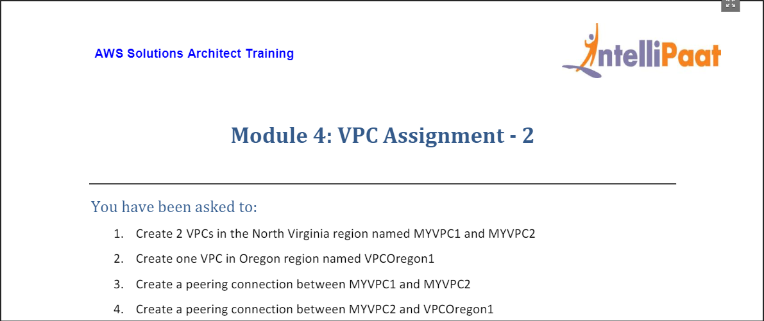

* Created 2 VPCs in North Virginia region named **myvpc1** and **myvpc2**.

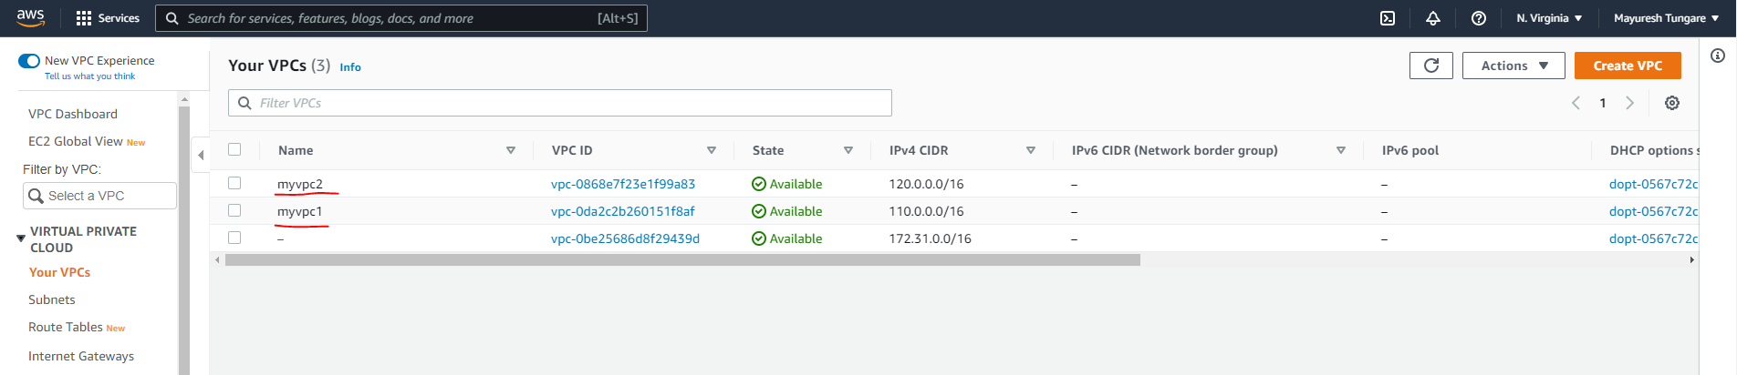

* Created one VPC in Oregon region named **vpcoregon1**

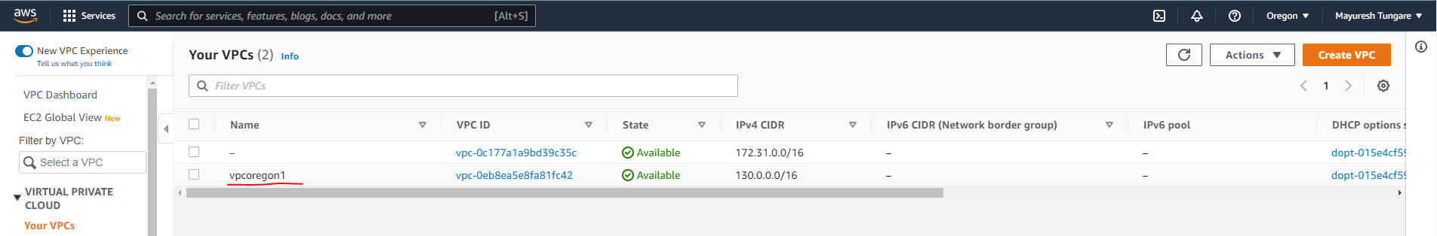

* Created a peering connection **PeerMod4-same-region** between **myvpc1** and **myvpc2**

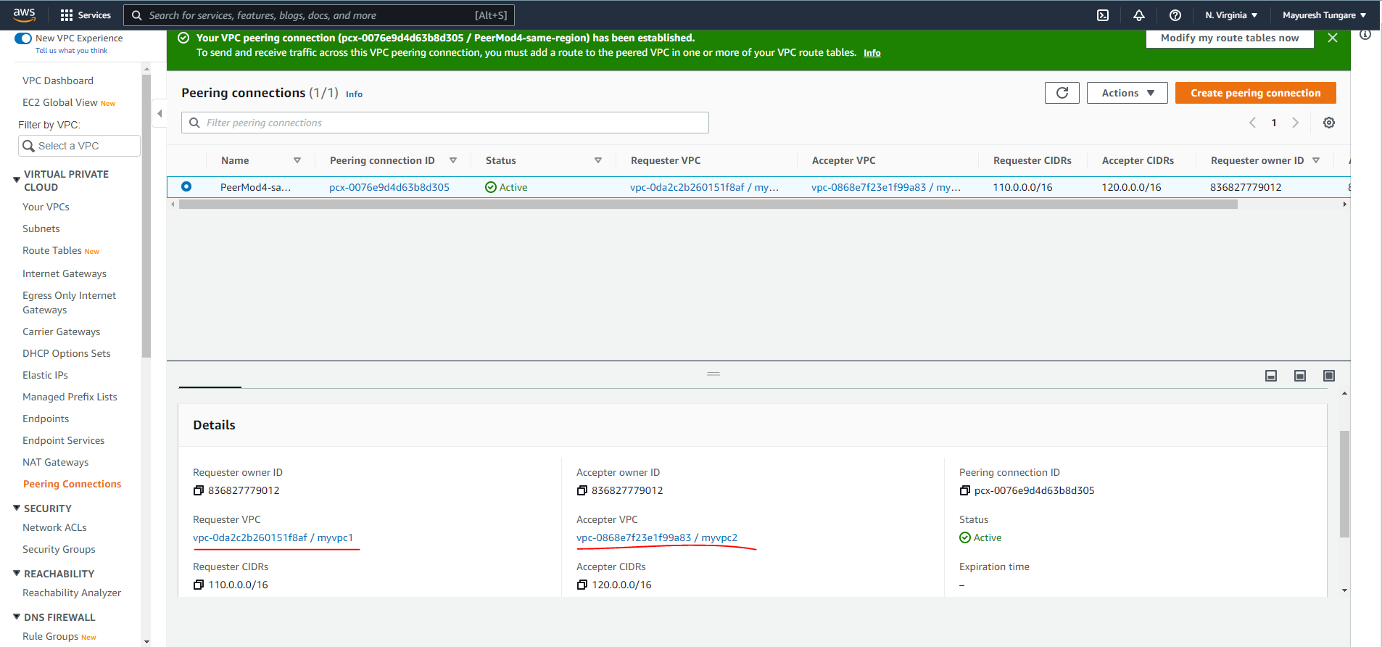

* Updated Route table for **myvpc1** as below:

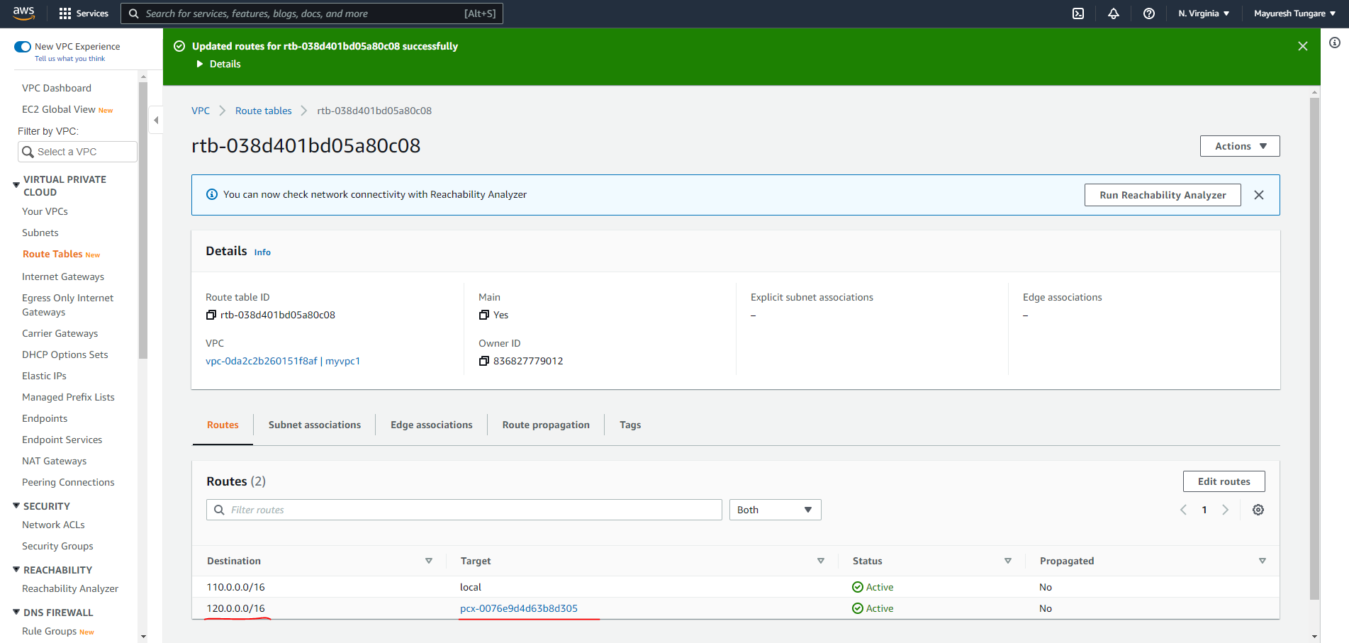

* Similarly, updated Route table for **myvpc2** as below:

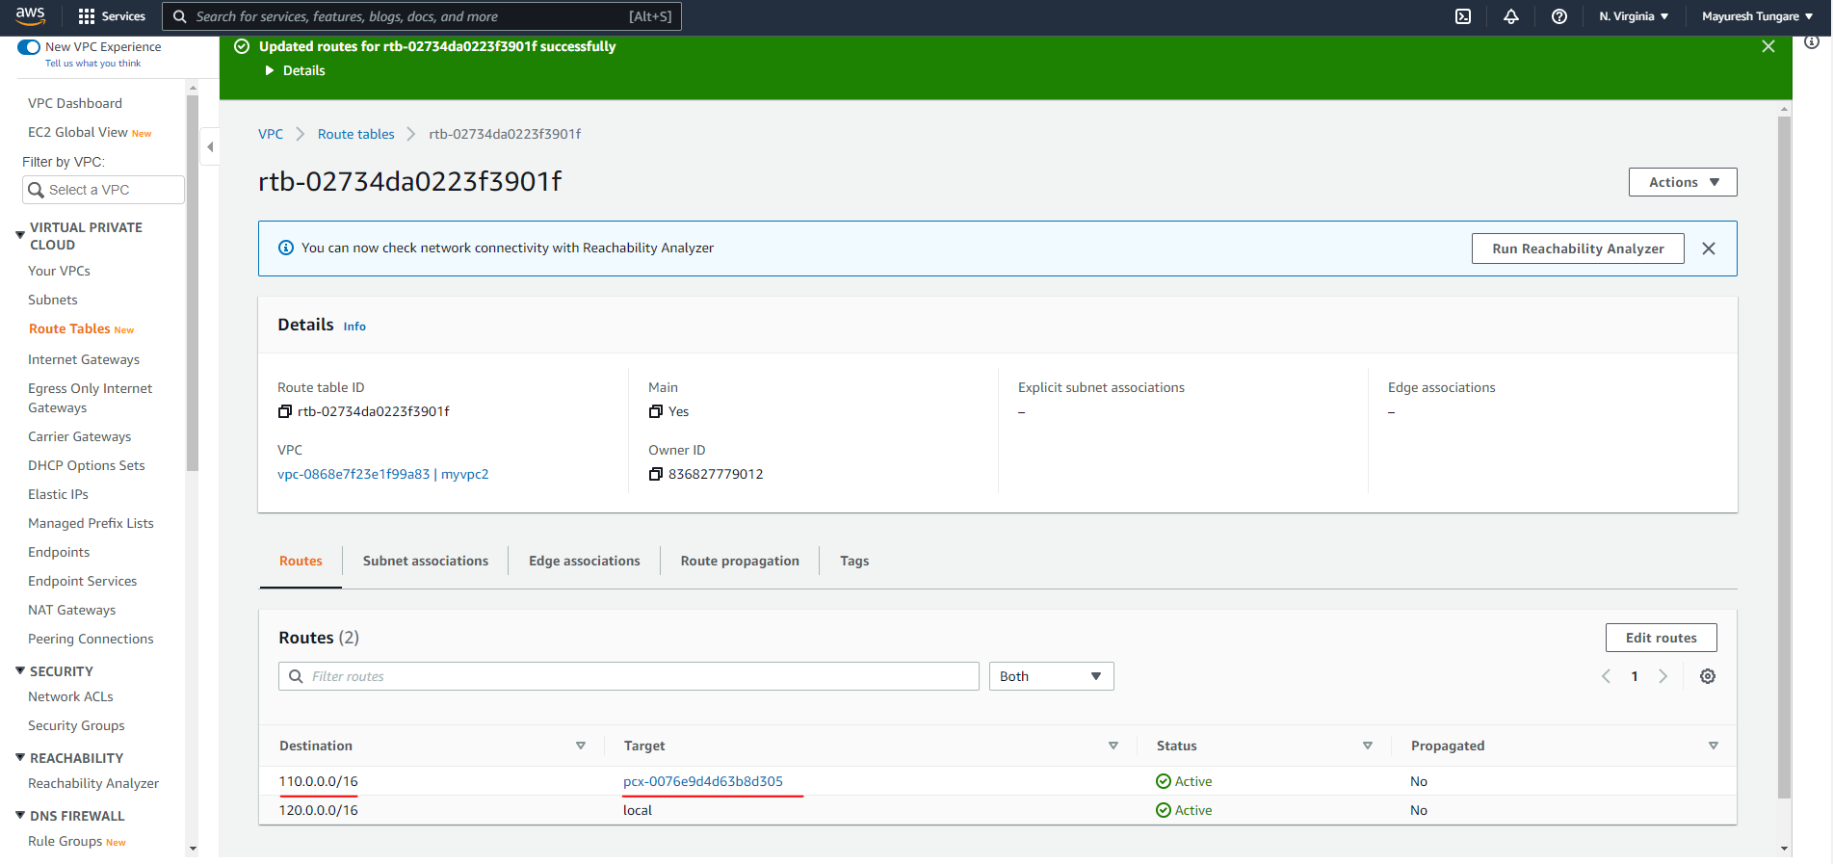

* Created a peering connection between **myvpc2** and **vpcoregon1** (Need to change region to accept from other end).

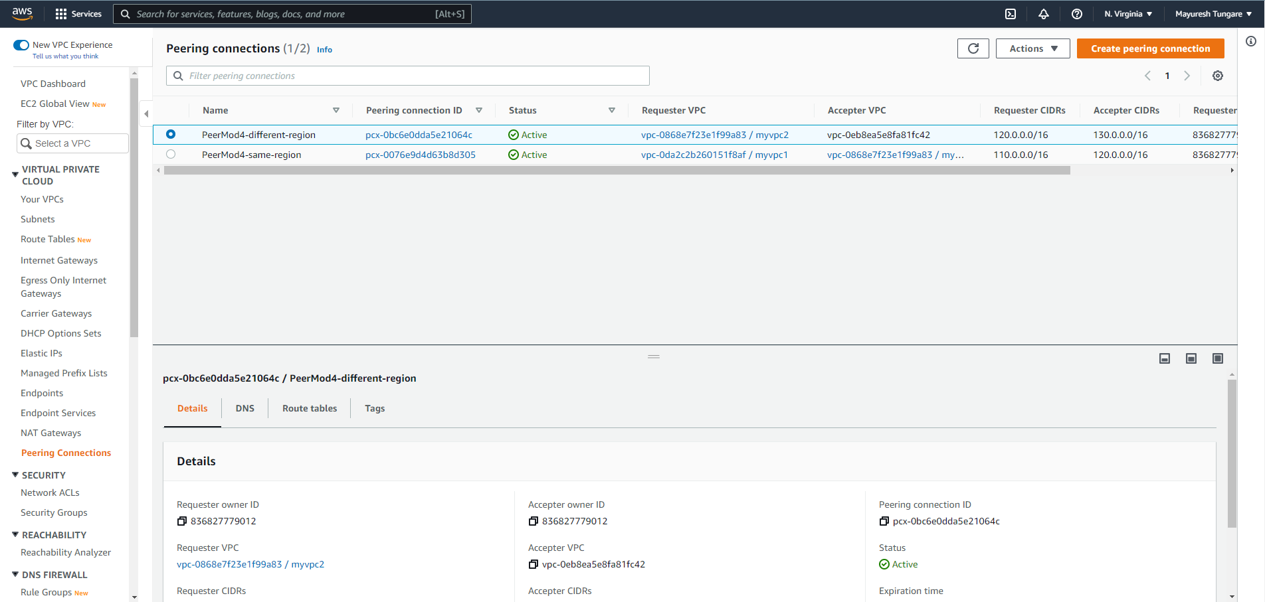

* Updated Route table for **myvpc2** as below:

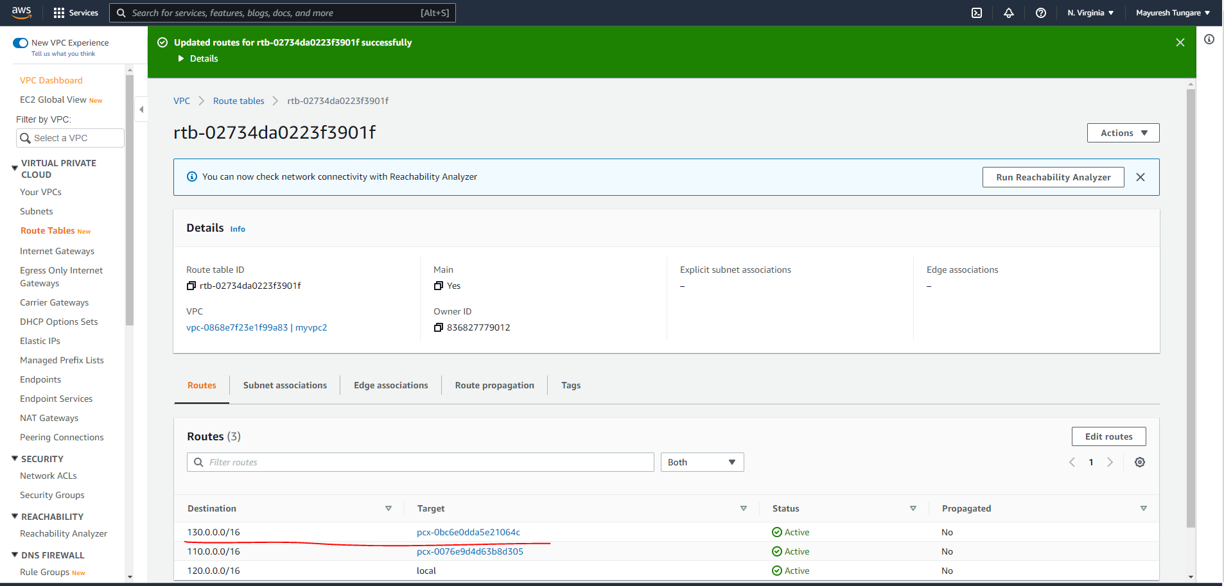

* Similarly, updated Route table for **vpcoregon1** as below:

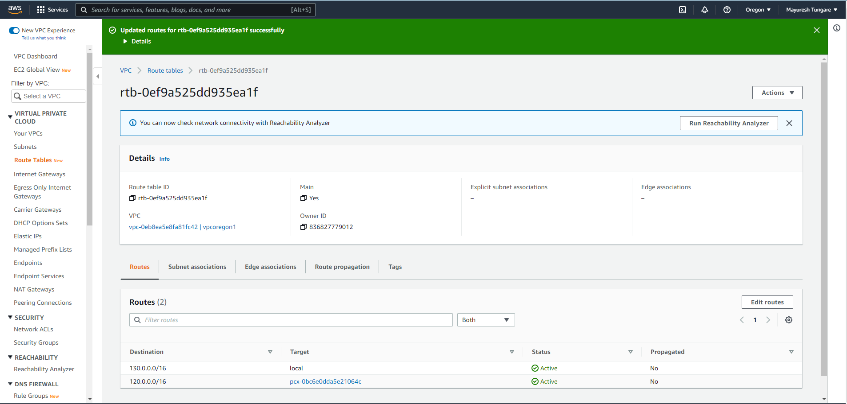

The assignment is now complete.